Service pages: Create new pages separate each service and banners include text
About us: Create about us page separate and add more information
Home page: Remove hyperlinks on these services
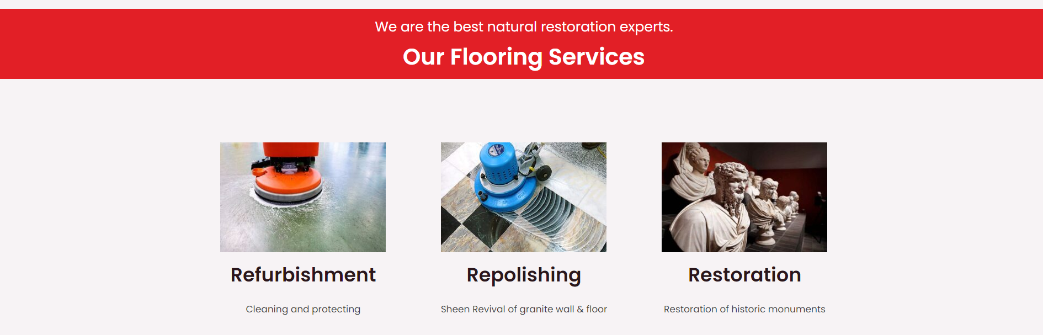

Home Page: Create arrow marks
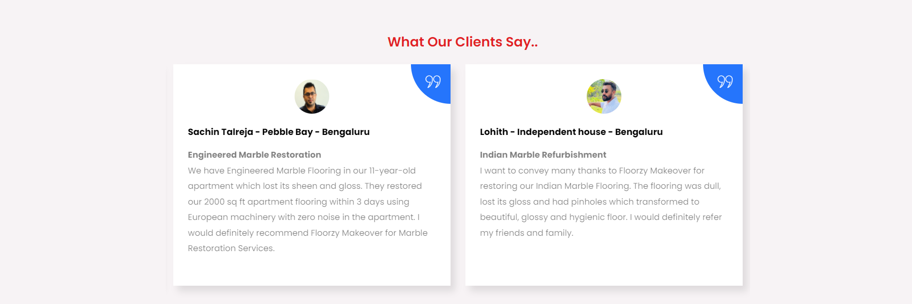

Create Thank page:
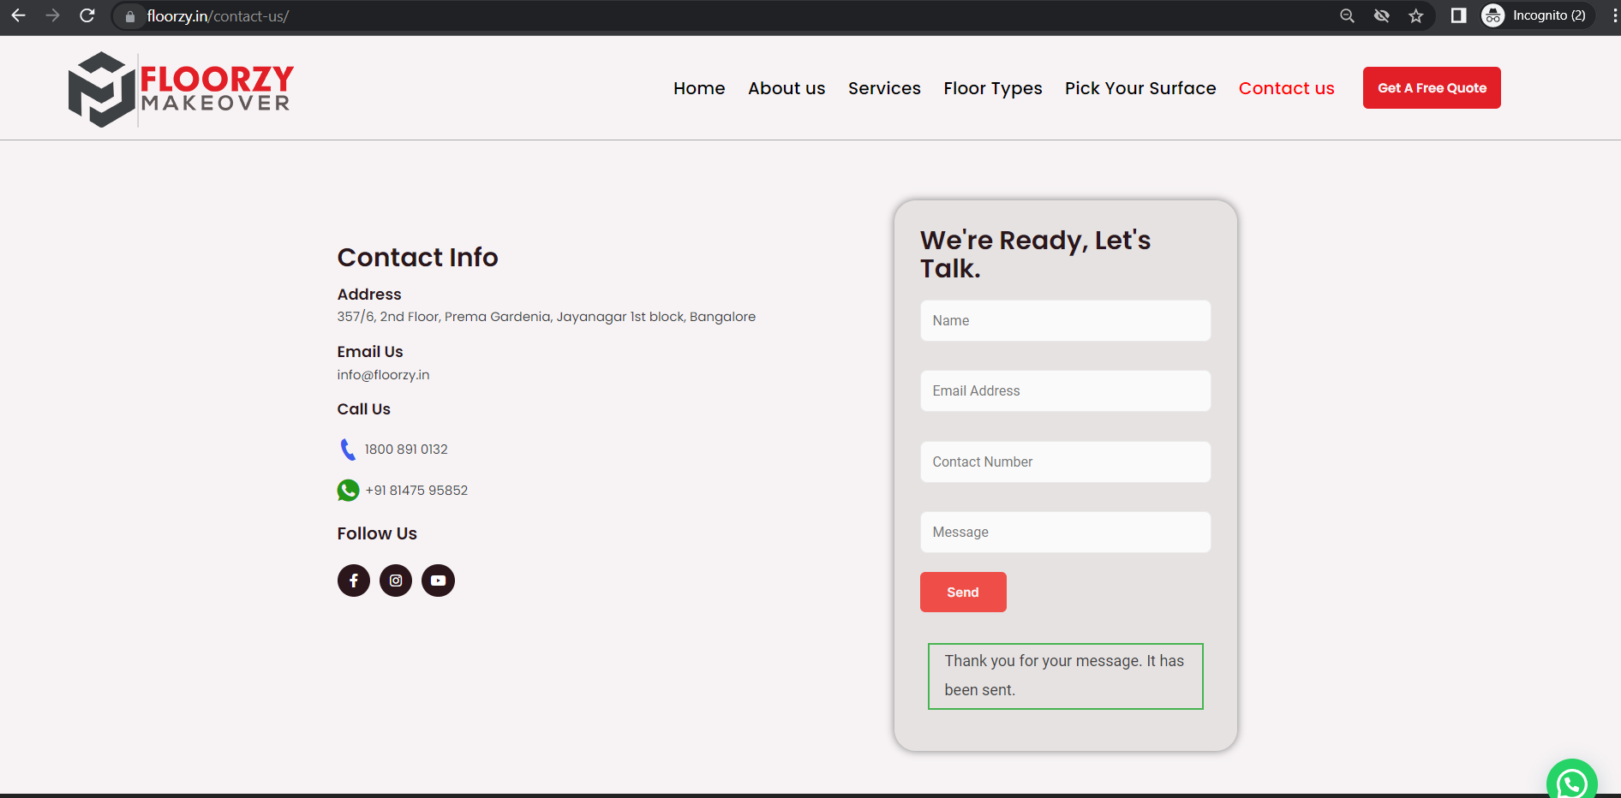

Thank you page create:

